Market Monitor - Afghanistan - 2026-06

Highlights
In June 2026, staple food prices in Afghanistan saw a broad-based monthly decrease, providing some relief to consumers, though costs remain significantly higher than last year. The national standard food basket cost fell to AFN 554.9 (↓1.5% MoM) but is still up 6.2% year-on-year (YoY).
The decline was led by sharp monthly drops in the prices of Sugar (↓5.0%), Wheat (↓4.0%), and high-quality Rice (↓3.2%). However, significant annual inflation persists for key items, with rice up 31.2% and sugar up 21.9% compared to June 2025. Pulses were a notable exception, with prices falling both month-on-month (↓1.3%) and year-on-year (↓12.3%).
Key Drivers:
- Improved commodity availability from ongoing harvests, which pushed down the prices of most staple foods.
- A stable and strong Afghani (AFN), which appreciated 9.6% against the USD year-on-year, helping to contain the cost of imported goods.
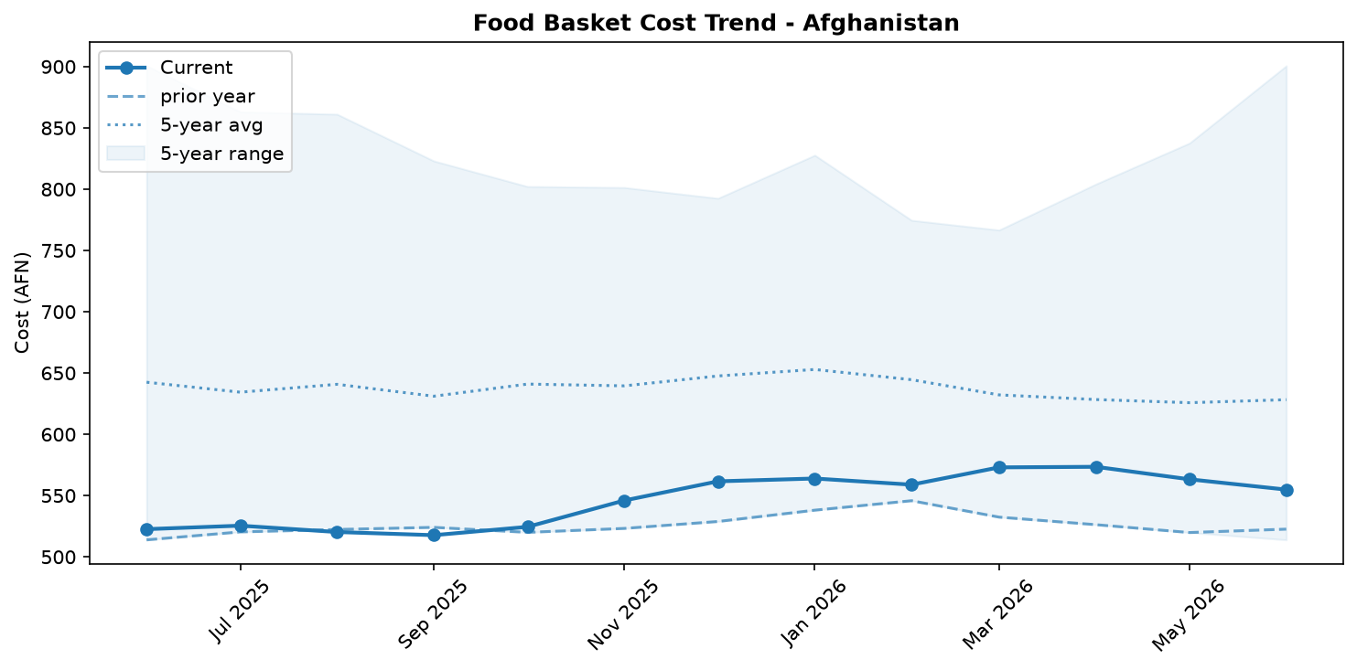
Food basket cost trend

Market Overview
In June 2026, Afghanistan's markets experienced a welcome, albeit potentially temporary, easing of food prices. The national average price of the standard food basket decreased by 1.5% month-on-month, a trend driven by broad-based price reductions across most staple commodities. Key drivers for this short-term relief include improved commodity availability from ongoing domestic harvests and sustained trade flows, which have kept markets well-supplied. Furthermore, the continued stability of the Afghani, which appreciated slightly against the US dollar, helped to moderate the cost of imported goods. This recent deflation provides a respite from the inflationary pressures observed in April, when food prices were a primary driver of a 1.1% monthly increase in the overall price level. Despite the monthly decrease, significant underlying pressures persist. The overall food basket remains 6.2% more expensive than a year ago, highlighting stubborn annual inflation. Moreover, sustained demand pressure, potentially exacerbated by the return of over 3.4 million nationals since early 2025, poses a risk to this fragile stability. Any disruption to supply chains or trade could quickly reverse the recent gains.

Commodity Analysis
A detailed analysis of commodity prices in June reveals a widespread monthly decrease, yet underscores severe year-on-year inflation for essential staples. Wheat, a primary staple, saw its price fall by 4.0% month-on-month, a direct result of the ongoing harvest. However, its price remains 12.0% higher than last year, with low-quality wheat flour tracking a similar pattern (-1.0% MoM, +11.1% YoY). Sugar experienced the sharpest monthly drop at -5.0%, but it is still 21.9% more expensive than in June 2025. The most alarming trend is seen in high-quality rice; despite a significant 3.2% monthly price reduction, it has the highest year-on-year inflation of any monitored item at a staggering 31.2%, severely impacting household purchasing power. Cooking oil prices also decreased slightly (-1.8% MoM) but remain elevated annually (+3.0% YoY). In contrast to these trends, pulses stand out as a positive exception, with prices decreasing both month-on-month (-1.3%) and significantly year-on-year (-12.3%). Conversely, salt was the only monitored commodity to register a price increase this month (+1.5%), contributing to its high annual inflation of 9.8%. While the monthly decreases offer relief, the double-digit annual inflation for rice, wheat, and sugar remains a major concern for food security.
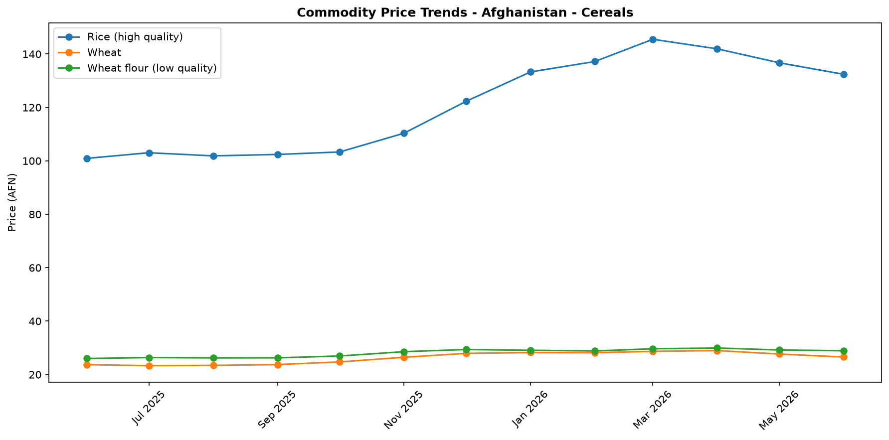
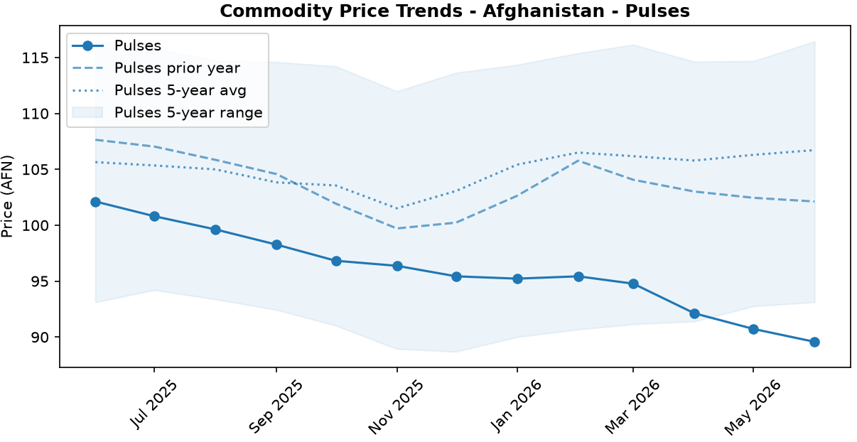
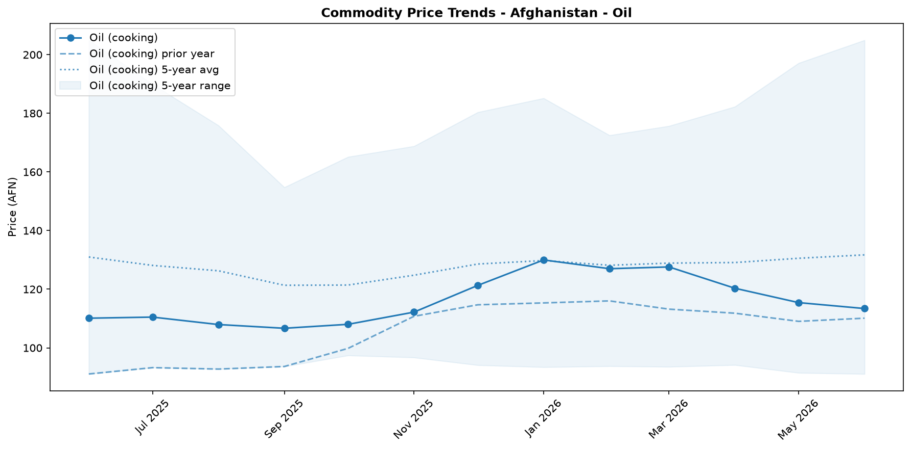
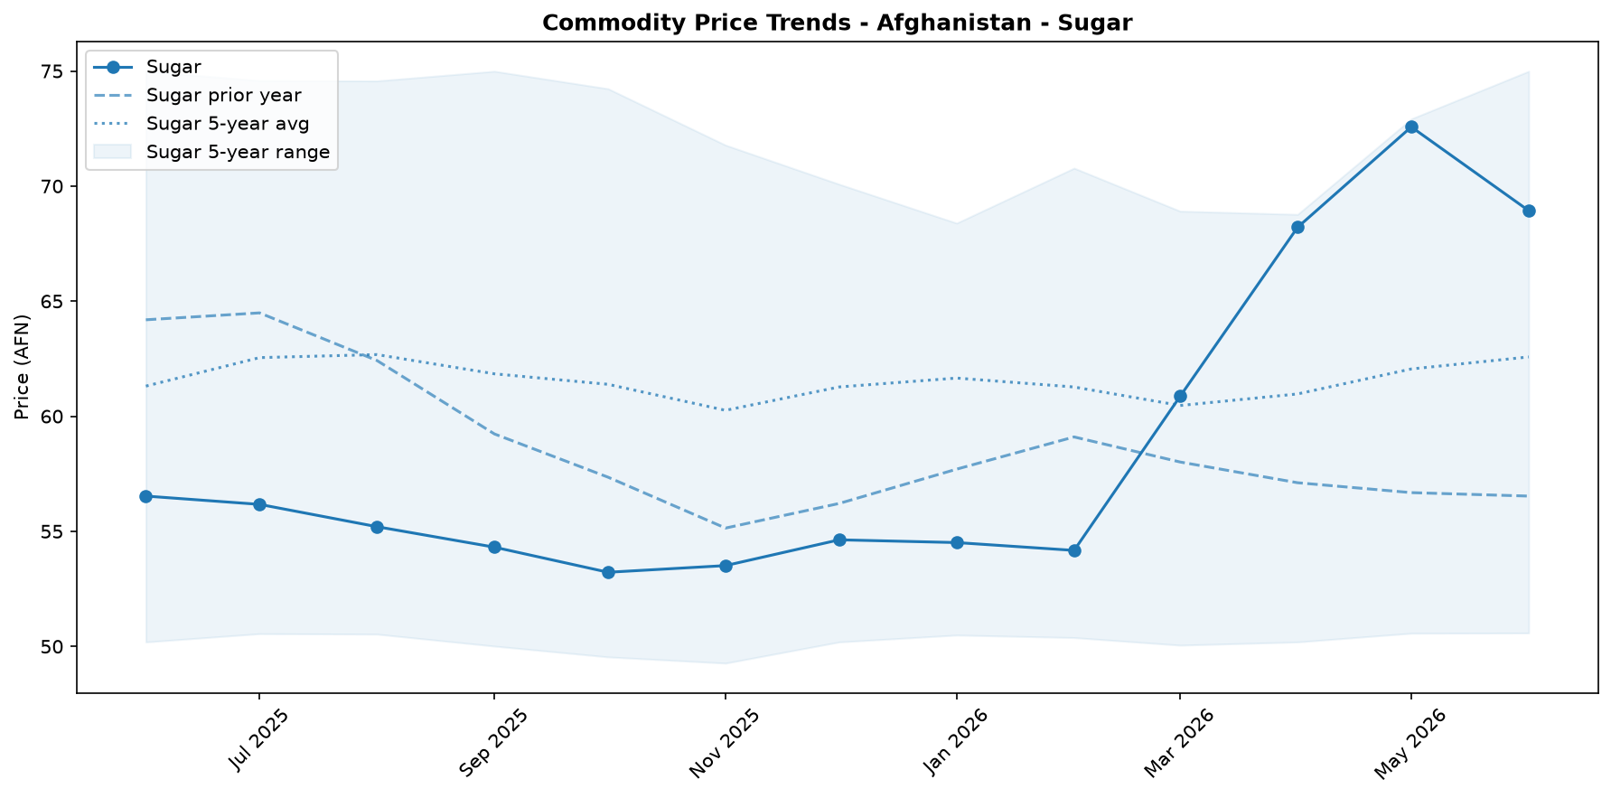
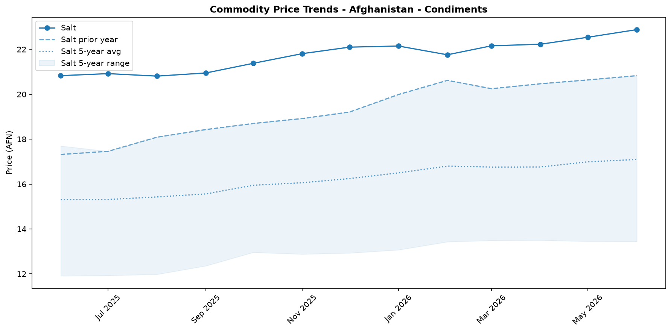

Regional Highlights
While the national-level data for June indicates a trend of decreasing prices, this aggregate figure likely conceals significant variations across Afghanistan's provinces. The current market stability is not uniform, and the benefits of price reductions are not being felt equally in all regions. Context from previous months highlights this disparity; in April 2026, for instance, there was a wide divergence in provincial inflation rates. Baghlan province reported the highest month-on-month inflation at +5.5%, while Parwan province experienced deflation, with prices falling by 2.5%. This pattern suggests that local supply chain efficiencies, security conditions, and access to markets continue to create distinct economic environments. While the ongoing harvest may be driving down prices in agricultural heartlands, other regions may still be grappling with affordability challenges. A granular, sub-national analysis is therefore critical to accurately assess household vulnerability and target assistance effectively. The following chart illustrates the varied price changes across different regions in the preceding period.
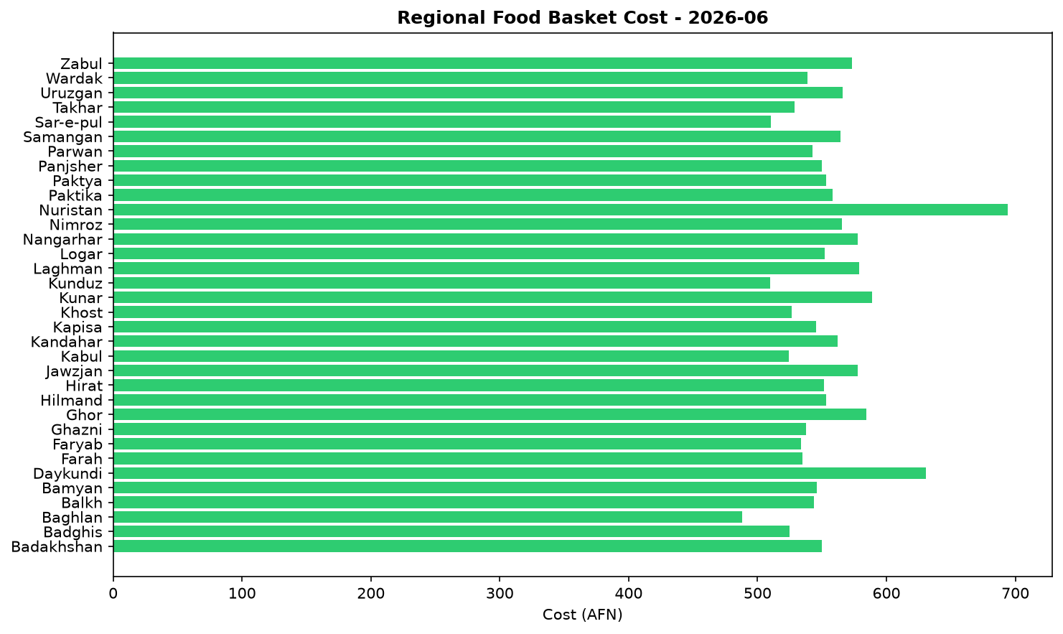

Exchange Rate Analysis
The Afghan Afghani (AFN) remained stable, trading at 63.5 AFN per USD. The currency appreciated slightly by 0.64 percent month-on-month, a minor strengthening that helps to marginally lower the cost of imported goods. This stability is part of a longer-term trend, with the AFN showing a significant 9.56 percent appreciation on a year-on-year basis. The stronger and more stable currency is a positive development for household purchasing power, as it helps to contain the local prices of key imported commodities. This is particularly important for food security, as it mitigates price increases for essential items like wheat, rice, cooking oil, and fuel, which are largely sourced from international markets.

References
- [rw_4217254] ReliefWeb (2026-06-22) Data for Afghanistan: Afghanistan Consumer Price Index (CPI) Report — April 2026
https://reliefweb.int/node/4217254
- [rw_4217179] ReliefWeb (2026-06-22) Afghanistan: Weekly Market Report: Issue 300: Week 3 – June 2026
https://reliefweb.int/node/4217179
- [rw_4217041] ReliefWeb (2026-06-19) Middle East Emergency: Three-Month Impact Report (March - May 2026)
https://reliefweb.int/node/4217041
- [rw_4216738] ReliefWeb (2026-06-17) Afghanistan | Population Movement (Returnees) - Operation update #5 (12-month update) (MDRAF018)
https://reliefweb.int/node/4216738
- [rw_4216714] ReliefWeb (2026-06-17) Atrocity Alert No. 487: Sudan, Afghanistan and Nigeria - Global Centre for the Responsibility to Protect
https://reliefweb.int/node/4216714
- [rw_4216641] ReliefWeb (2026-06-17) Hunger Hotspots FAO-WFP Early Warnings on Acute Food Insecurity - June to November 2026 outlook
https://reliefweb.int/node/4216641
- [rw_4216603] ReliefWeb (2026-06-17) REACH Afghanistan Quarterly Food Security Monitoring (QFSM), Methodology Note (June 2026)
https://reliefweb.int/node/4216603
- [rw_4216569] ReliefWeb (2026-06-17) A journey to safer motherhood post-earthquake in Kunar
https://reliefweb.int/node/4216569
- [rw_4216543] ReliefWeb (2026-06-17) Asia and the Pacific: Snapshot of El Niño & Middle East Crisis (as of 12 June 2026)
https://reliefweb.int/node/4216543
- [rw_4216537] ReliefWeb (2026-06-17) Afghanistan: Monthly Market Report Issue 72: May 2026
https://reliefweb.int/node/4216537
- [seerist_1028928] Seerist (2026-06-10) Military co-operation between Taliban, Russia unlikely to significantly boost Taliban’s capabilities
- [seerist_1028903] Seerist (2026-06-09) Sovereign risk remains EXTREME despite improvement in tax revenues
- [seerist_1028629] Seerist (2026-05-20) New law on distribution of state land underscores EXTREME regulatory risk
- [seerist_1028557] Seerist (2026-05-15) Clashes over gold mine, Taliban’s poppy destruction policy underscore EXTREME security risk
- [seerist_1028494] Seerist (2026-05-12) Uptick in Pakistan-Afghan Taliban hostilities likely following complex attack in Khyber Pakhtunkhwa

